# Name: Giang Duong

# CS 156 SPRING 2021

# Professor Sanjoy Paul

# Homework 4

**Assignment:**

1. Tabulate the results showing

(a) Path length, (b) Path cost, (c) Number of nodes expanded and (d) Processing time from all three searches dfs, bfs and ucs for the following scenarios:

* 1. **questA**
  2. **questB**
  3. **questC**
  4. **questD**
  5. **SJSU**
  6. **noway**

1. Which search algorithm performed the best? Why do you think so?
2. Did the performance of the algorithms vary with the type of the maze file? Why?

|  |  |  |  |  |
| --- | --- | --- | --- | --- |
| **SJSU.txt** | | | | |
|  | **PATH LENGTH** | **COST** | **NUMBER OF EXPANED** | **PROCESSING TIME** |
| **BFS** | 33 | 388 | 758 | 0.0088 |
| **DFS** | 303 | 2548 | 325 | 0.0034 |
| **UCS** | 36 | 306 | 659 | 0.0092 |
|  |  |  |  |  |
| **QUEST A** | | | | |
|  | **PATH LENGTH** | **COST** | **NUMBER OF EXPANED** | **PROCESSING TIME** |
| **BFS** | 7 | 98 | 76 | 0.001 |
| **DFS** | 7 | 98 | 7 | 0.0001 |
| **UCS** | 7 | 98 | 91 | 0.0011 |
|  |  |  |  |  |
| **QUEST B** | | | | |
|  | **PATH LENGTH** | **COST** | **NUMBER OF EXPANED** | **PROCESSING TIME** |
| **BFS** | 60 | 631 | 483942 | 73.4645 |
| **DFS** | 452 | 3767 | 1339 | 0.0175 |
| **UCS** | 74 | 550 | 493477 | 29.434 |
|  |  |  |  |  |
|  |  |  |  |  |
| **QUEST C** | | | | |
|  | **PATH LENGTH** | **COST** | **NUMBER OF EXPANED** | **PROCESSING TIME** |
| **BFS** | 31 | 452 | 701 | 0.0089 |
| **DFS** | 315 | 2724 | 758 | 0.0085 |
| **UCS** | 31 | 452 | 1275 | 0.0186 |
|  |  |  |  |  |
| **QUEST D** | | | | |
|  | **PATH LENGTH** | **COST** | **NUMBER OF EXPANED** | **PROCESSING TIME** |
| **BFS** | 31 | 452 | 701 | 0.0094 |
| **DFS** | 315 | 2724 | 758 | 0.0083 |
| **UCS** | 31 | 452 | 1275 | 0.0181 |
|  |  |  |  |  |
|  |  |  |  |  |
| **QUEST E** | | | | |
|  | **PATH LENGTH** | **COST** | **NUMBER OF EXPANED** | **PROCESSING TIME** |
| **BFS** | 8 | 112 | 135 | 0.0016 |
| **DFS** | 8 | 112 | 8 | 0.0001 |
| **UCS** | 8 | 112 | 363 | 0.0057 |
|  |  |  |  |  |
| **QUEST F** | | | | |
|  | **PATH LENGTH** | **COST** | **NUMBER OF EXPANED** | **PROCESSING TIME** |
| **BFS** | 71 | 445 | 120050 | 5.1255 |
| **DFS** | 628 | 5104 | 920 | 0.0121 |
| **UCS** | 73 | 437 | 81689 | 2.2479 |
|  |  |  |  |  |
| **QUEST G** | | | | |
|  | **PATH LENGTH** | **COST** | **NUMBER OF EXPANED** | **PROCESSING TIME** |
| **BFS** |  |  |  |  |
| **DFS** | 663 | 5318 | 1239 | 0.015 |
| **UCS** | 94 | 563 | 2748632 | 195.2317 |
|  |  |  |  |  |
| **QUEST H** | | | | |
|  | **PATH LENGTH** | **COST** | **NUMBER OF EXPANED** | **PROCESSING TIME** |
| **BFS** | 25 | 276 | 1233 | 0.015 |
| **DFS** | 105 | 916 | 177 | 0.0027 |
| **UCS** | 32 | 218 | 1186 | 0.0222 |
|  |  |  |  |  |
| **QUEST L** | | | | |
|  | **PATH LENGTH** | **COST** | **NUMBER OF EXPANED** | **PROCESSING TIME** |
| **BFS** | 40 | 446 | 4441 | 0.0495 |
| **DFS** | 370 | 3086 | 548 | 0.007 |
| **UCS** | 47 | 299 | 3044 | 0.0442 |
|  |  |  |  |  |
| **NOWAY** | | | | |
|  | **PATH LENGTH** | **COST** | **NUMBER OF EXPANED** | **PROCESSING TIME** |
| **BFS** | 20 | 163 | 315 | 0.0034 |
| **DFS** | 116 | 931 | 116 | 0.0018 |
| **UCS** | 20 | 163 | 275 | 0.0034 |

PART B:

For DFS, we can see that they will take more path length and cost than others but the number of expanded will less than other. We can say DFS has better for Space but worser for Time. I think DFS should be the best perform algorithms since from the lecture, professor said that space is more critical in search problems because memory cannot magically grow

For BFS, we can see that take more of number expanded (cost more space and time).

For UCS, we can see that they use space and time at worst case O(n logn), it was not too bad as the BFS but we can see they still take more time and space vs DFS.

PART C:

The performance of the algorithms vary with the type of the maze file because we can see with different algorithms, they has their strength and weakness. For DFS, they will easy find the solution if they have only one path. BFS will do better if their solution lies near the parent nodes and UCS will do the best if solution lies near the cost less than cheapeset final solution.

PART A:

QUESTA:

BFS:

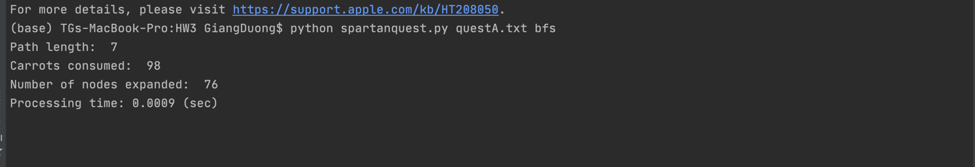

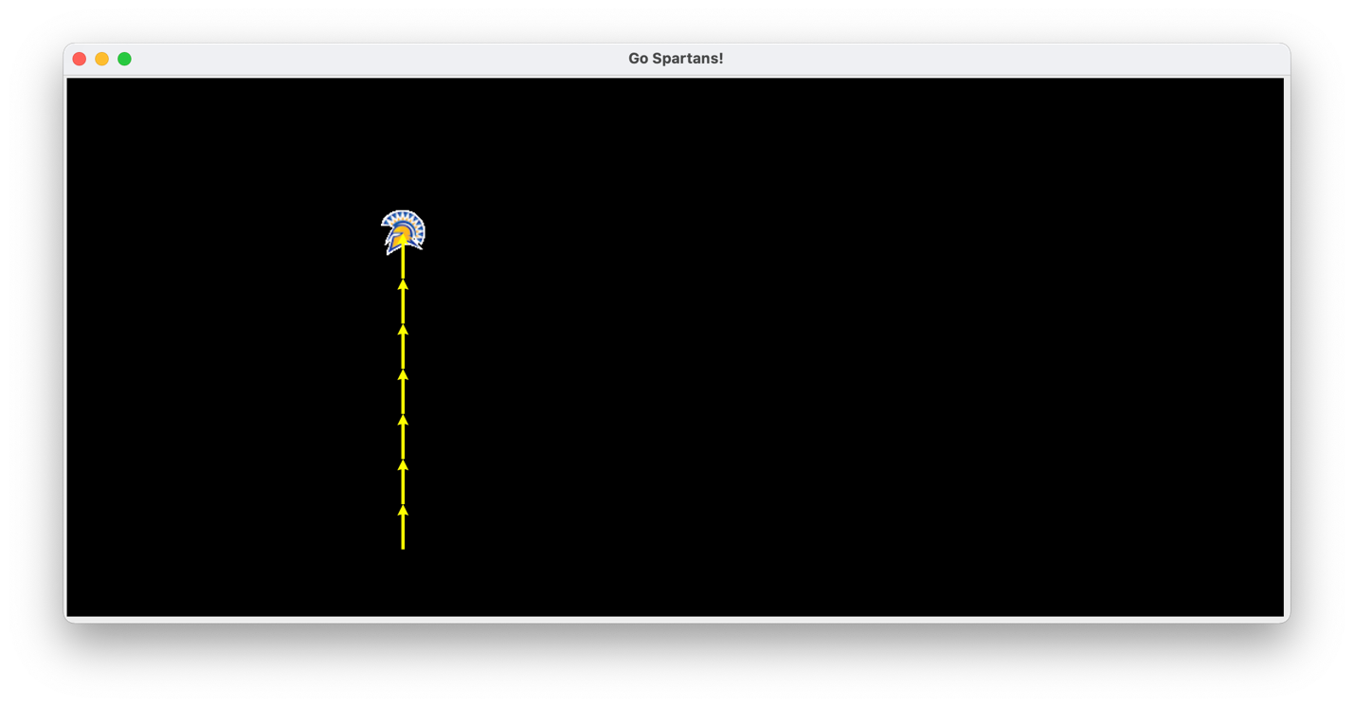

DFS:

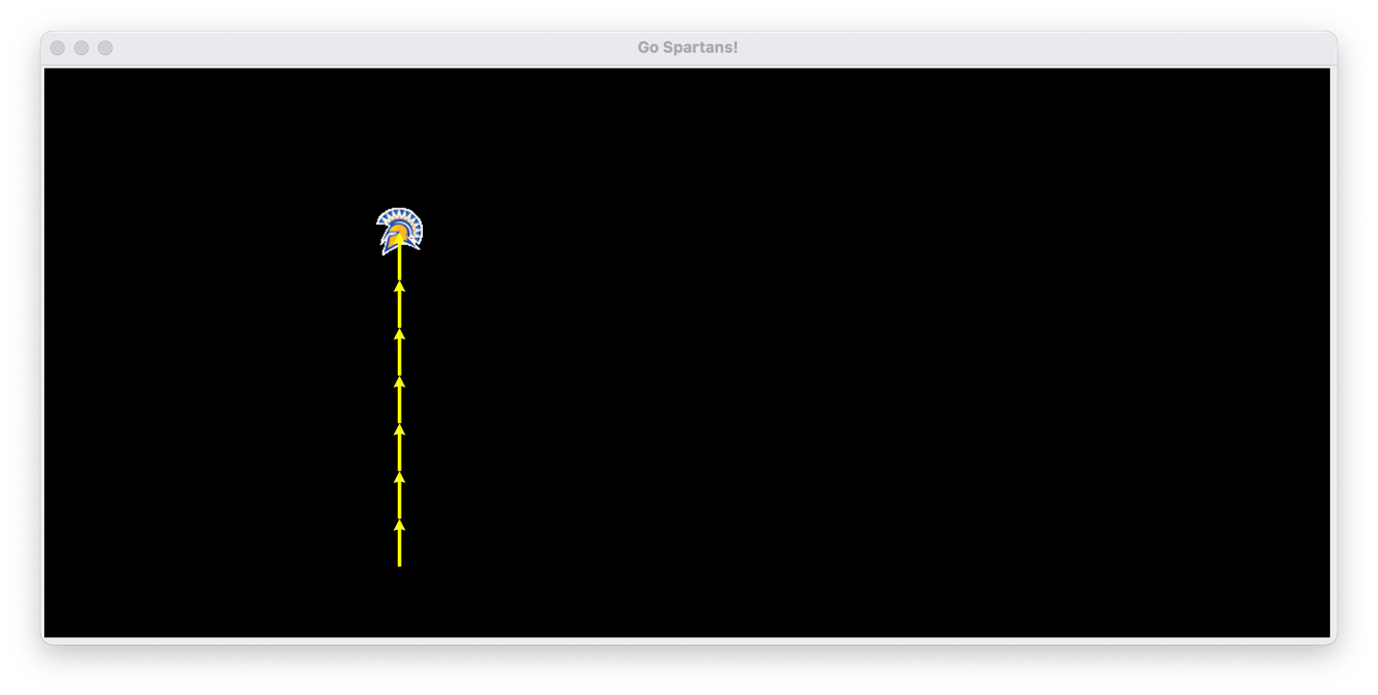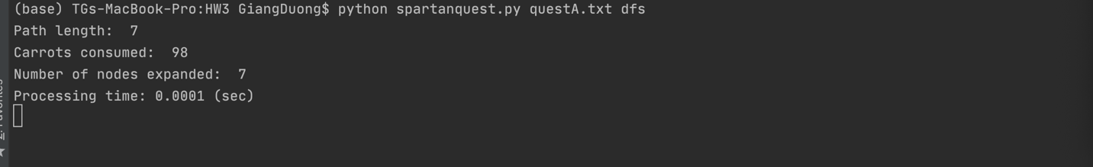

UCS: 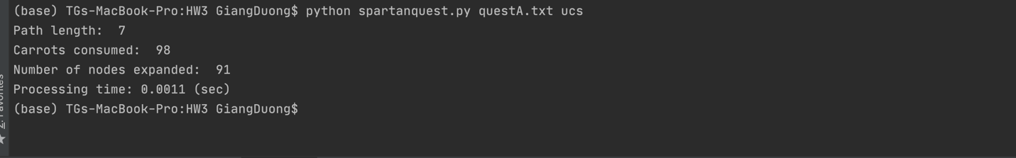



QUEST B:

BFS:

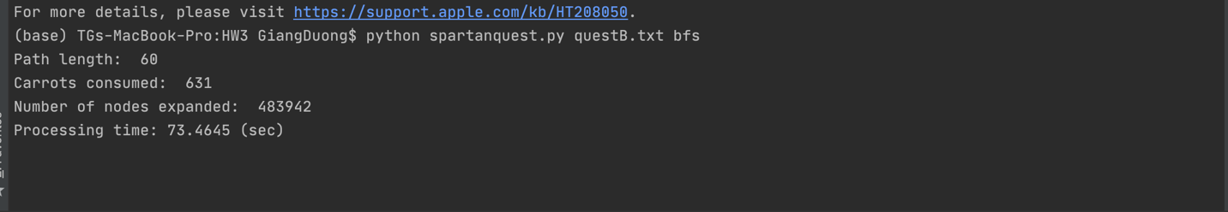

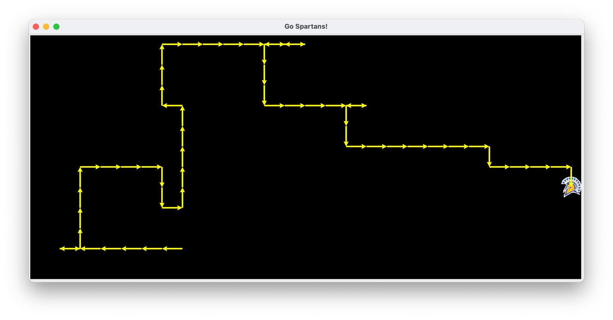

DFS:

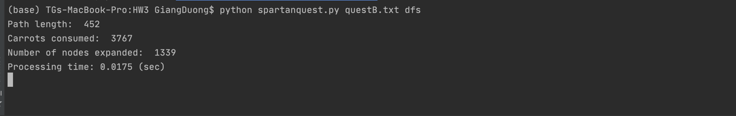

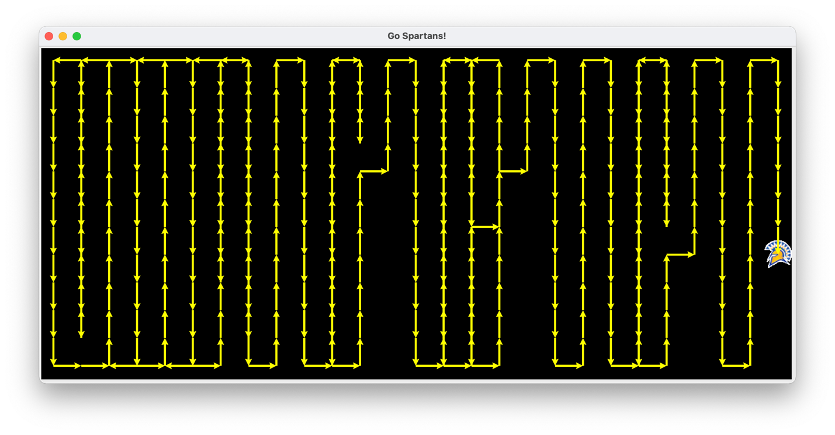

UCS:

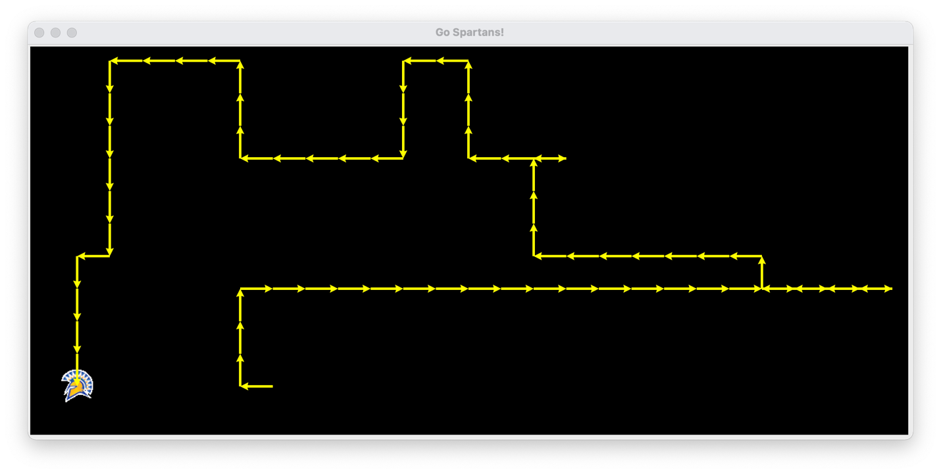

QUEST C:

BFS:

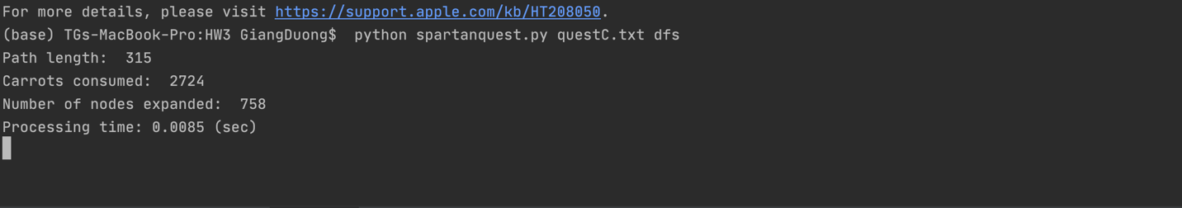

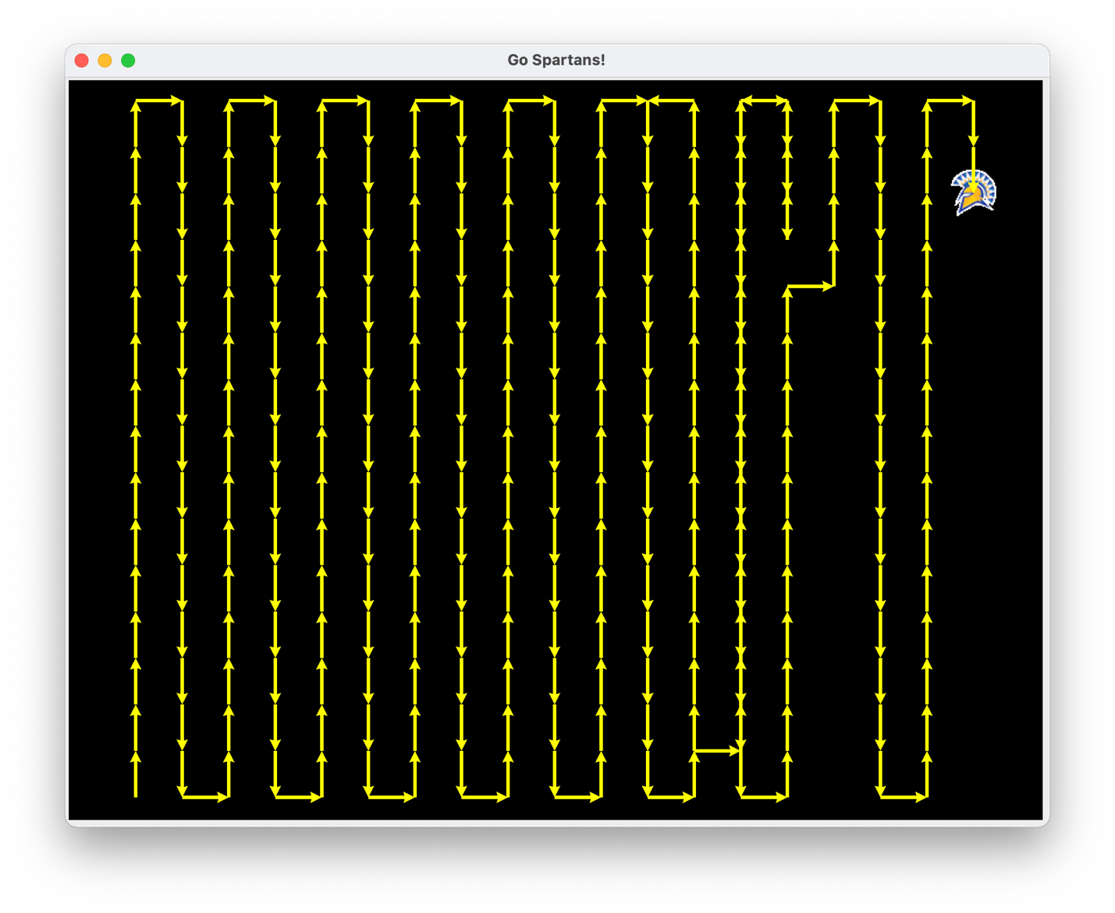

DFS:

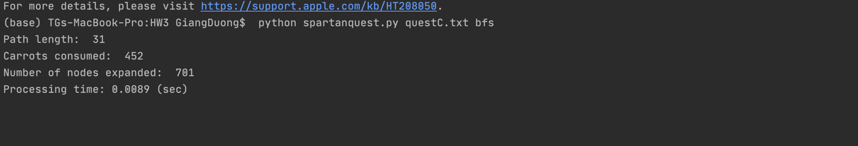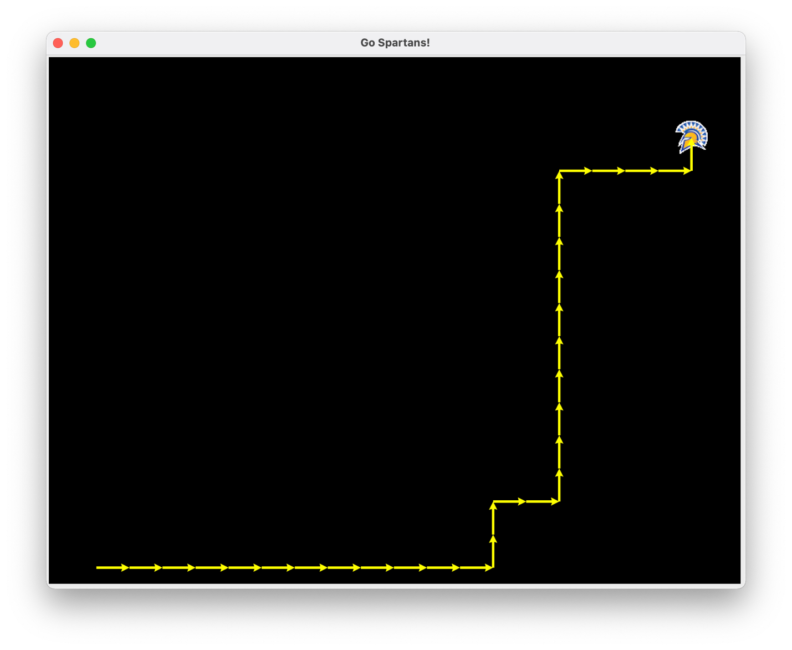

UCS:

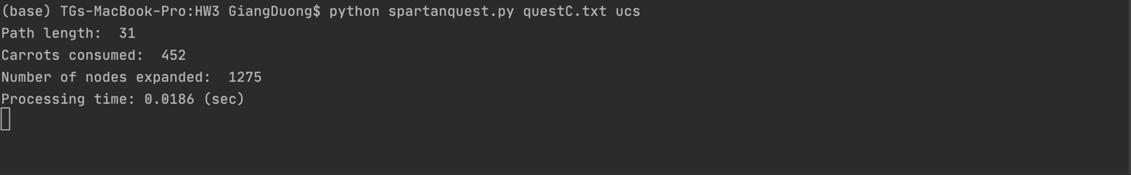

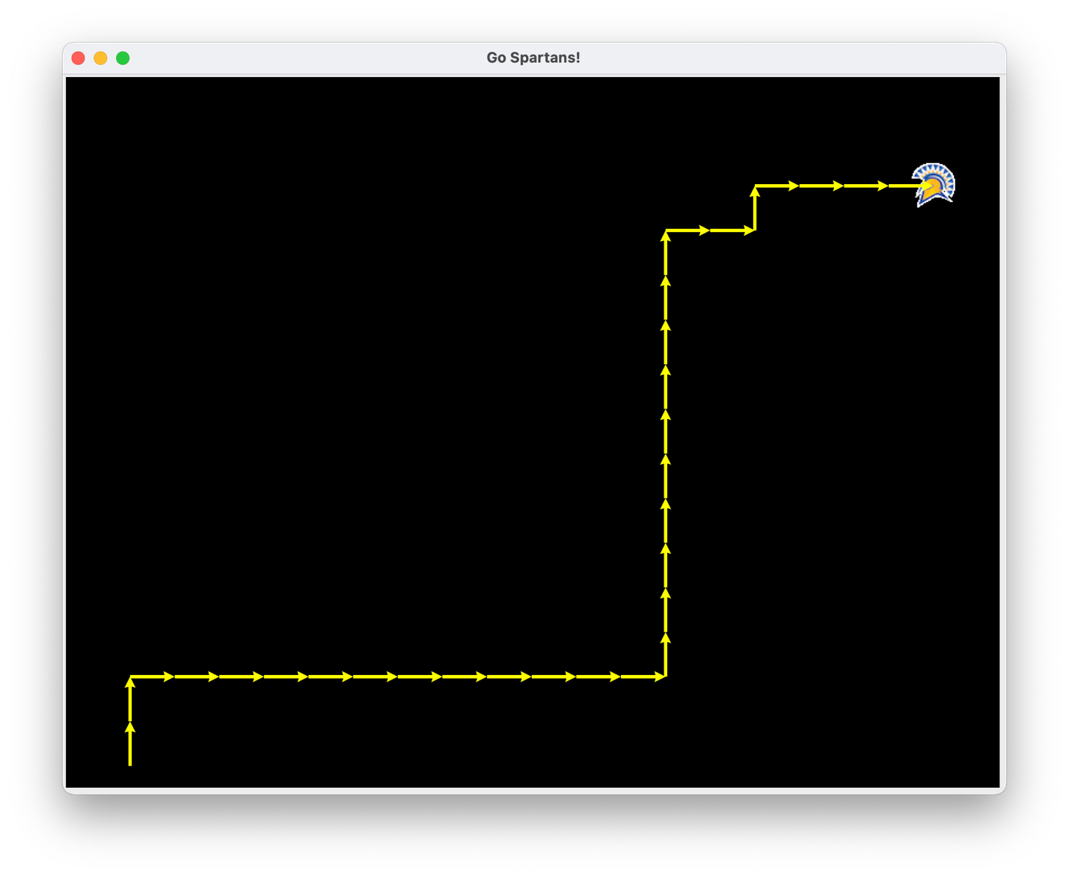

QUEST D:

BFS:

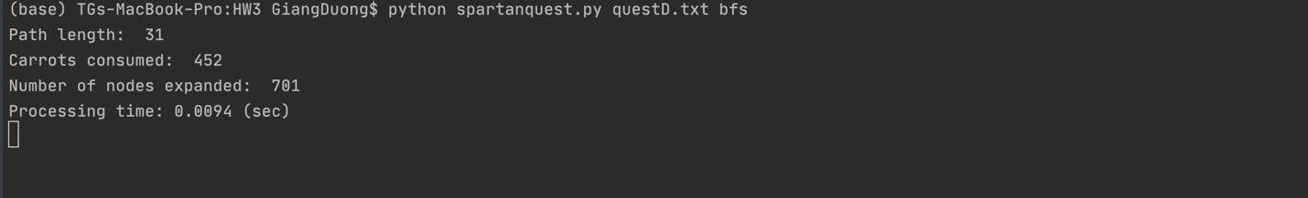

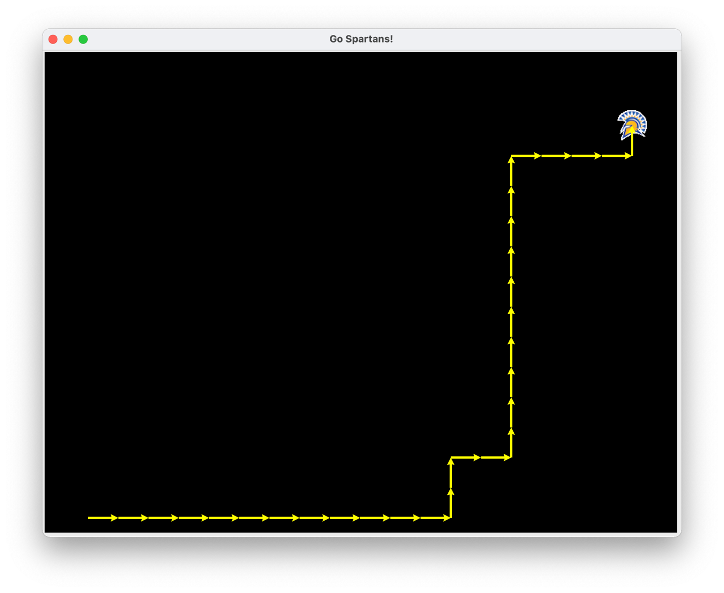

DFS:

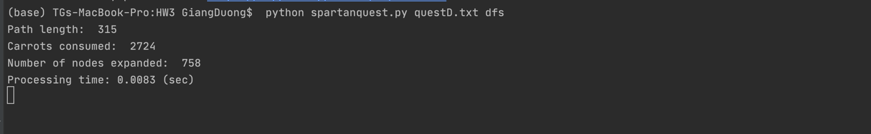

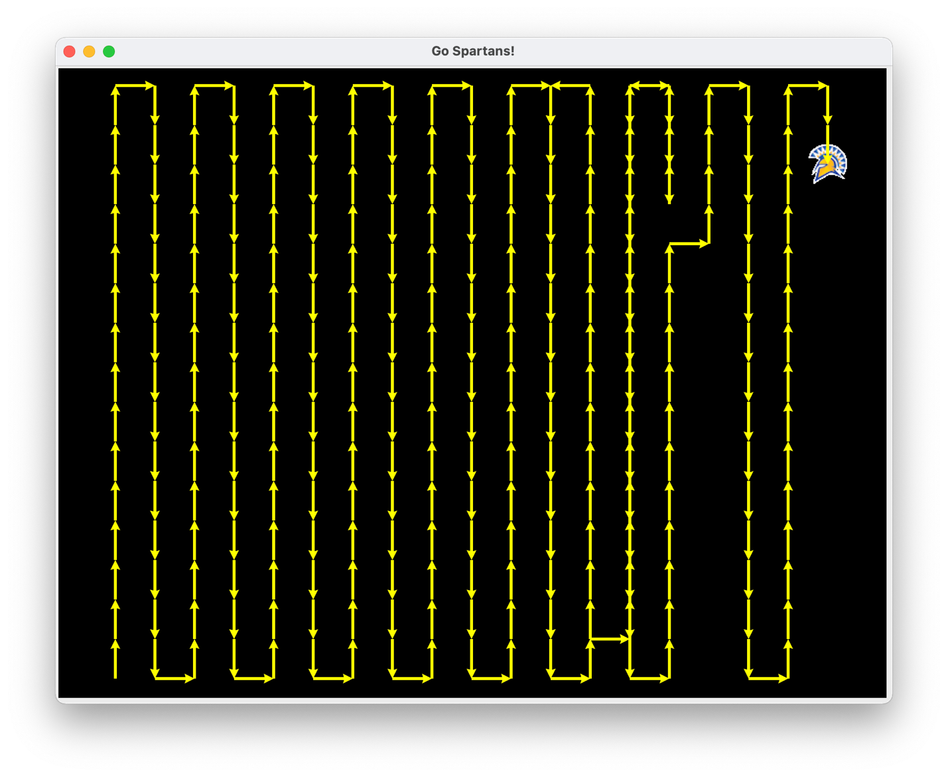

UCS:



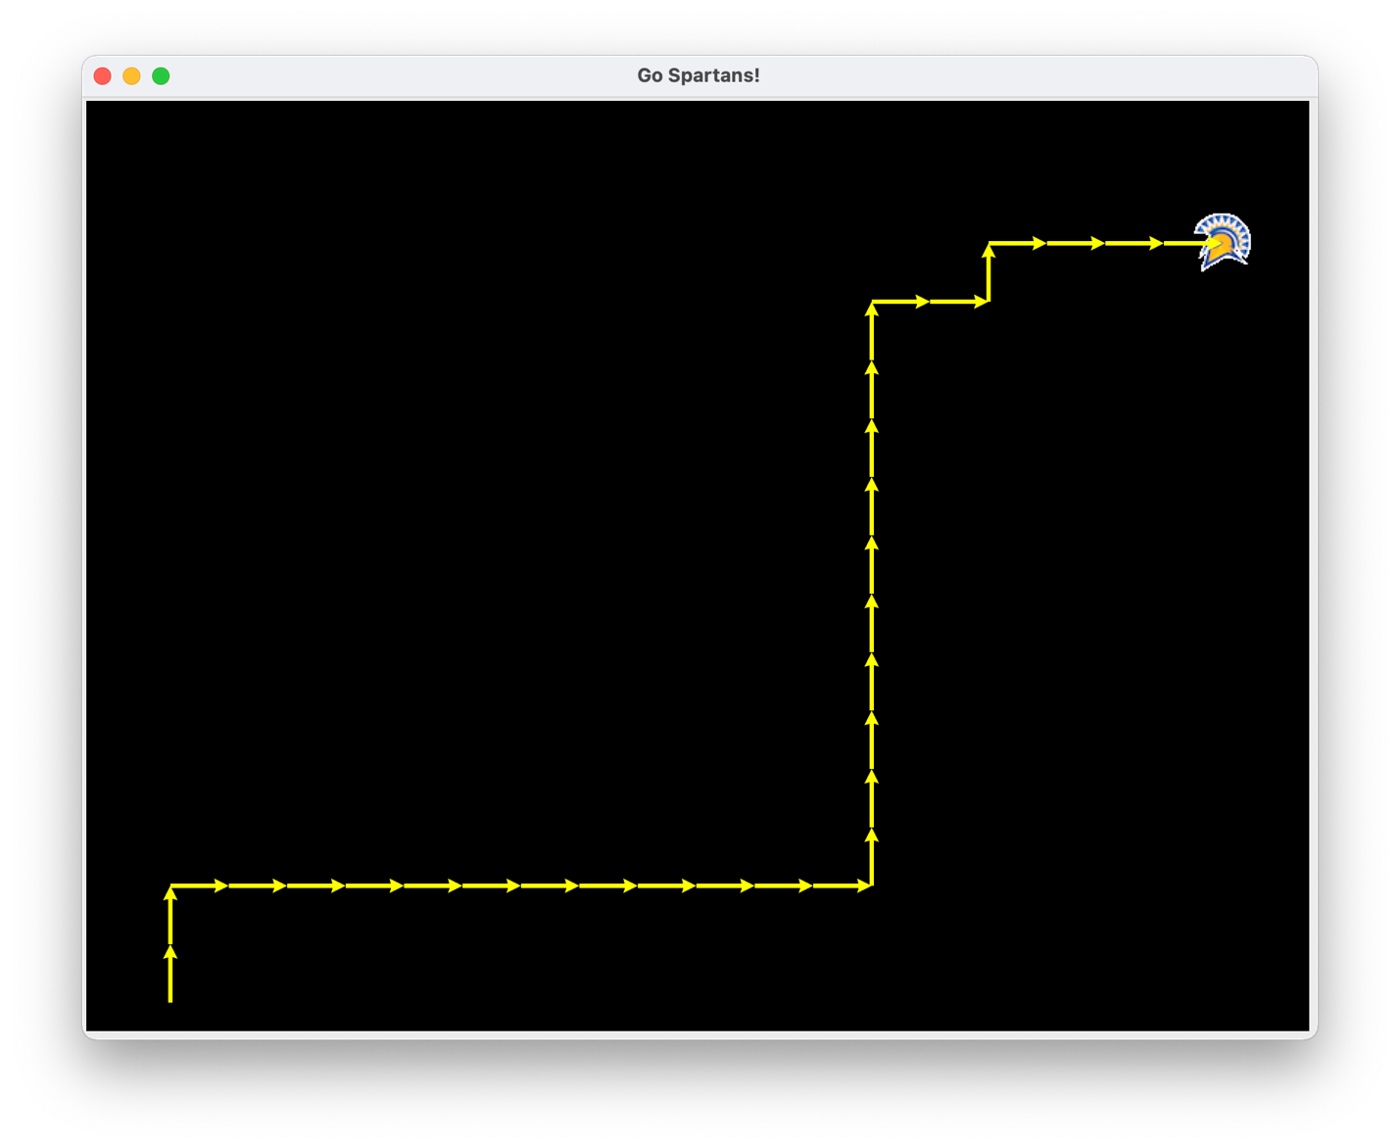

QUEST E: 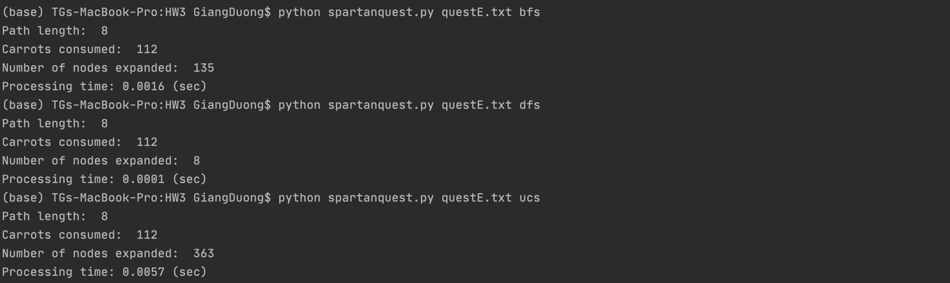

BFS:

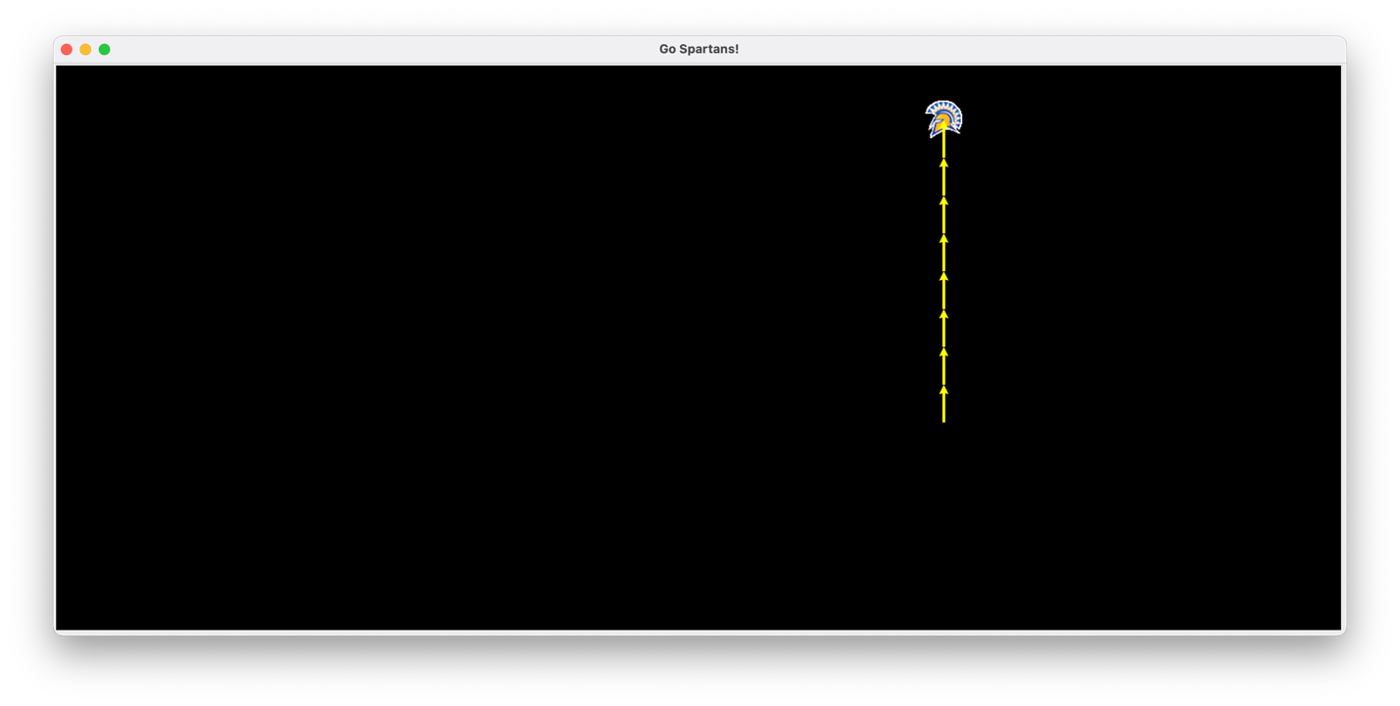

DFS:

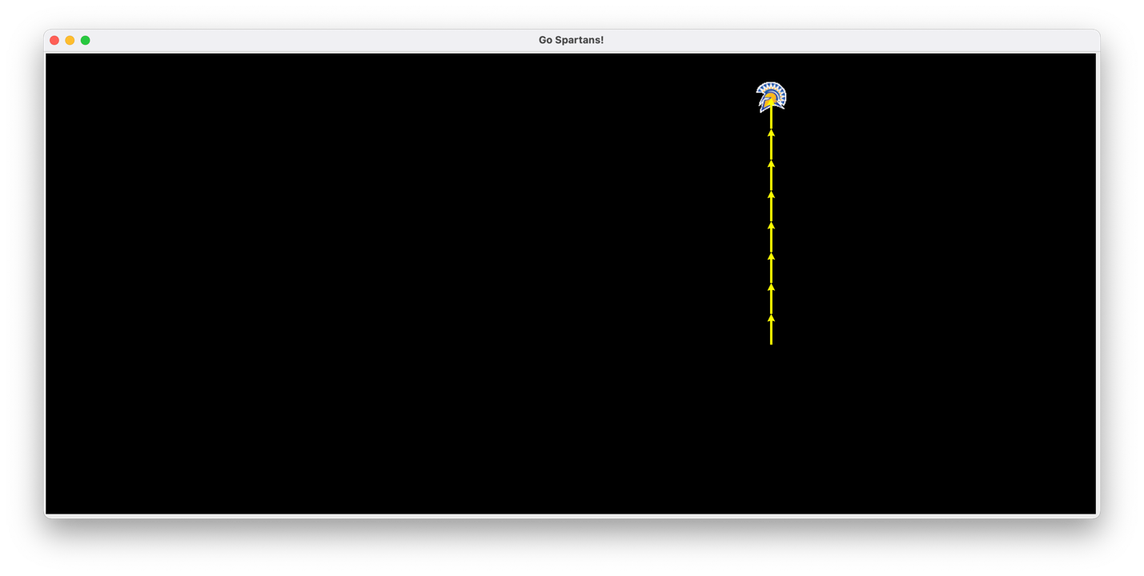

UCS:

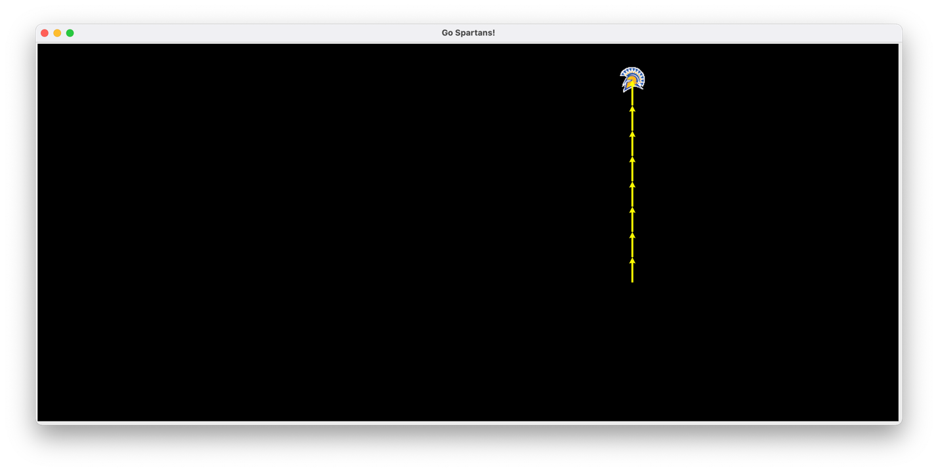

QUEST F:

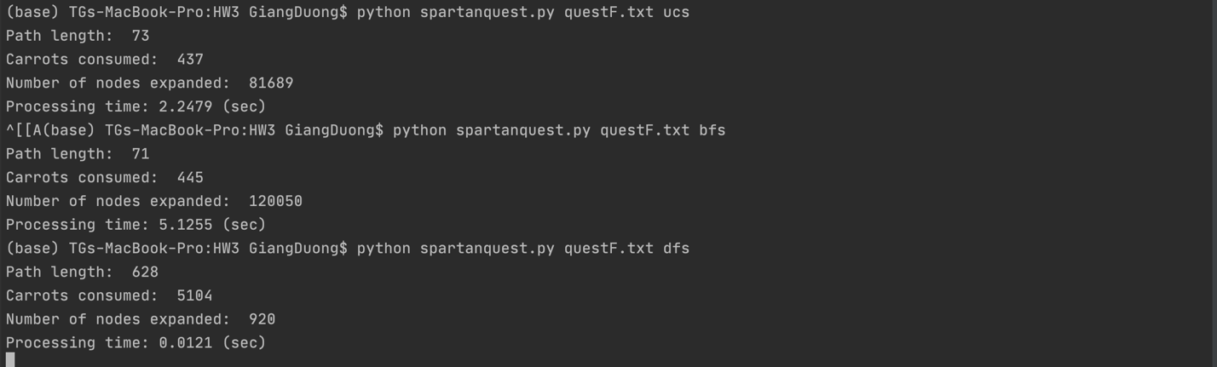

BFS:

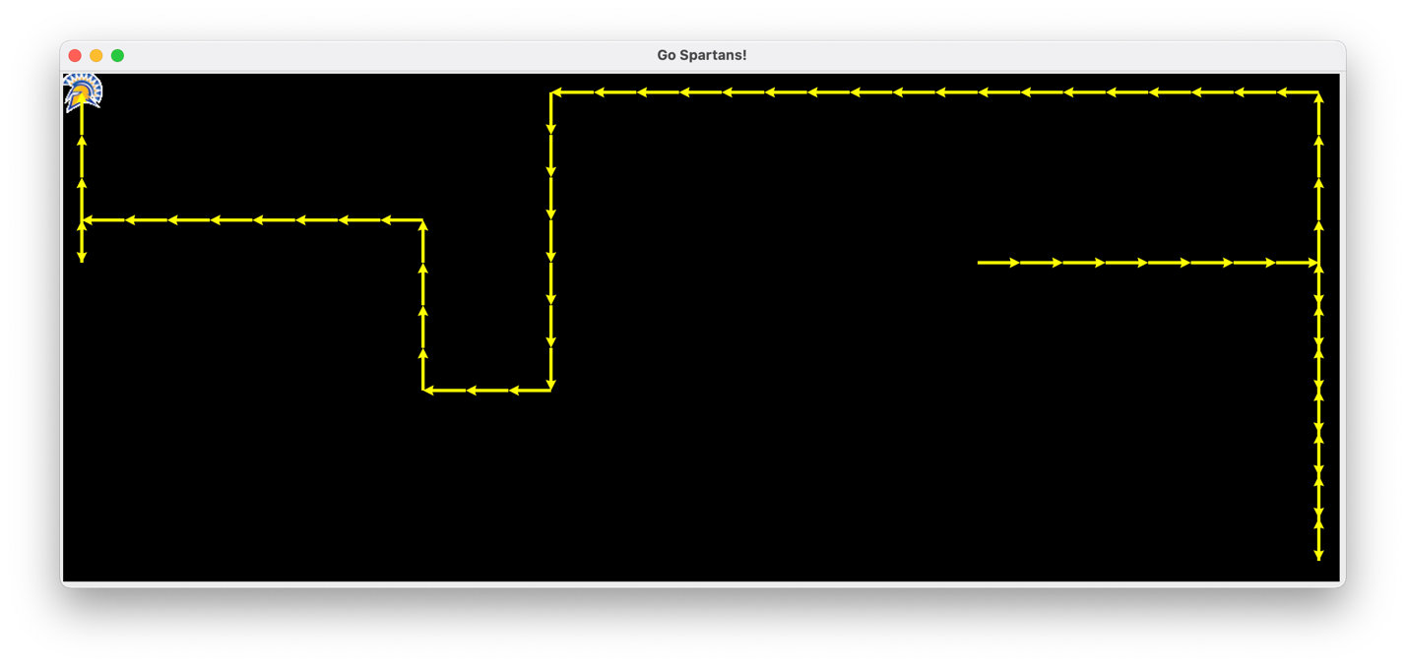

DFS:

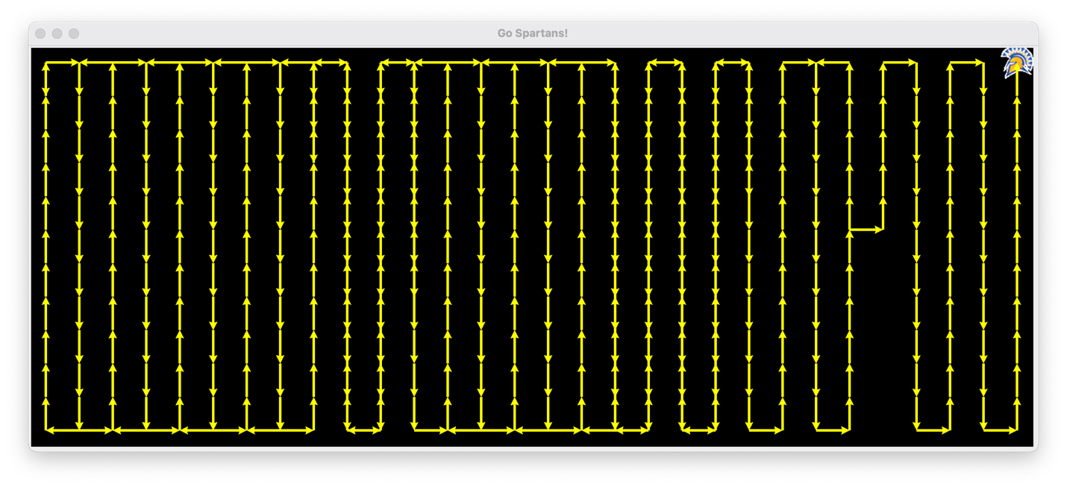

UCS:

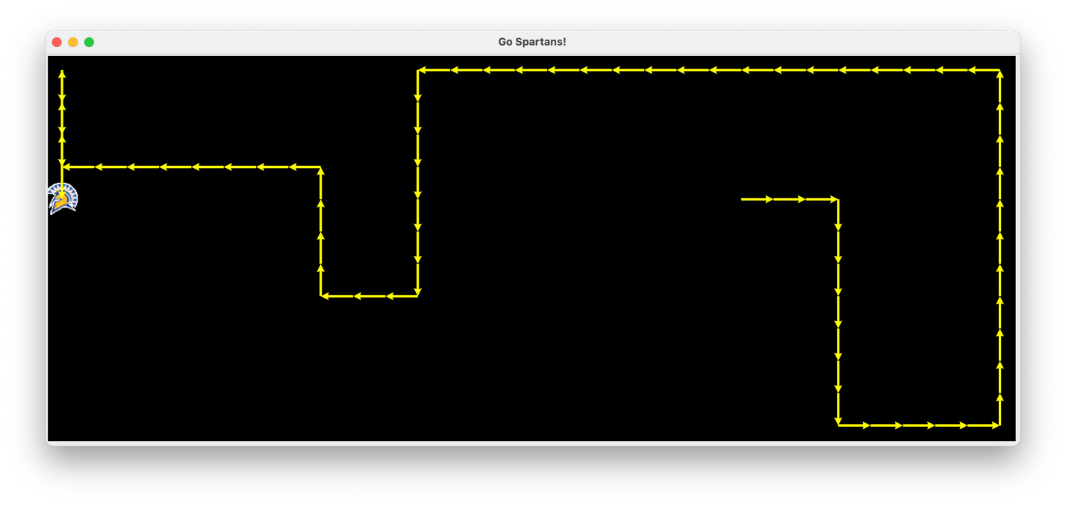

QUEST G:

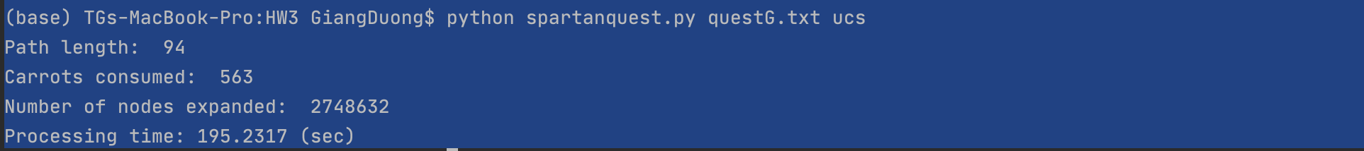

BFS:

DFS:

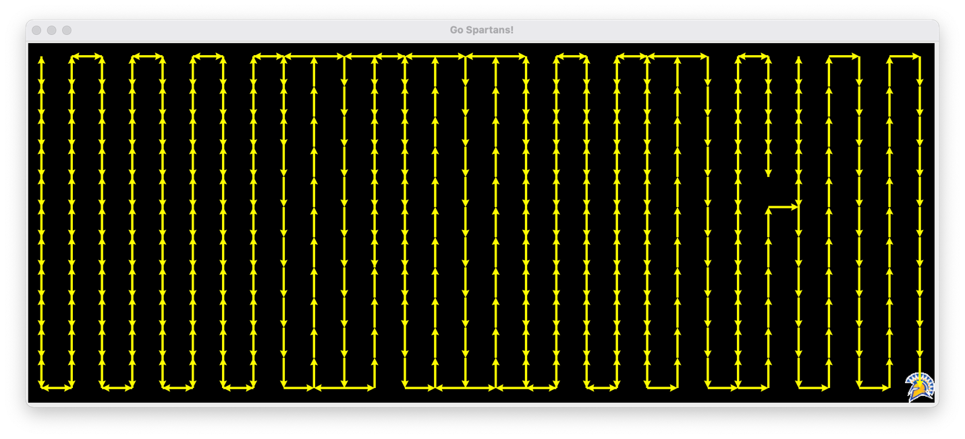

UCS:

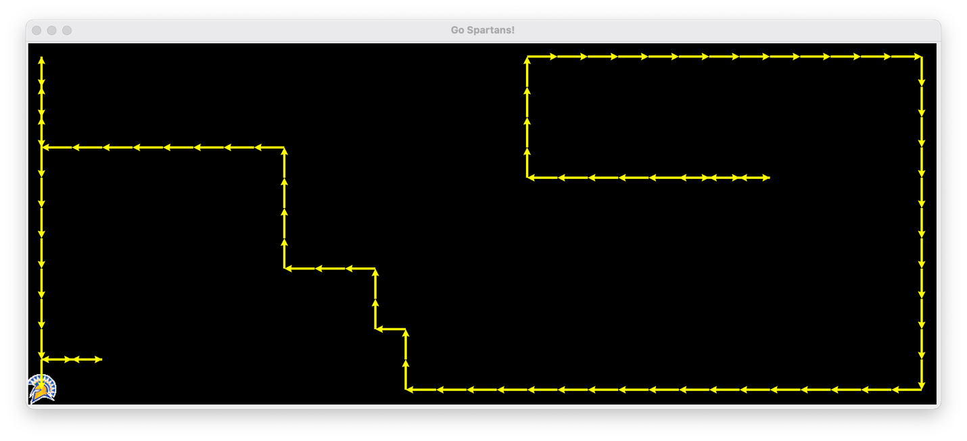

QUEST H:

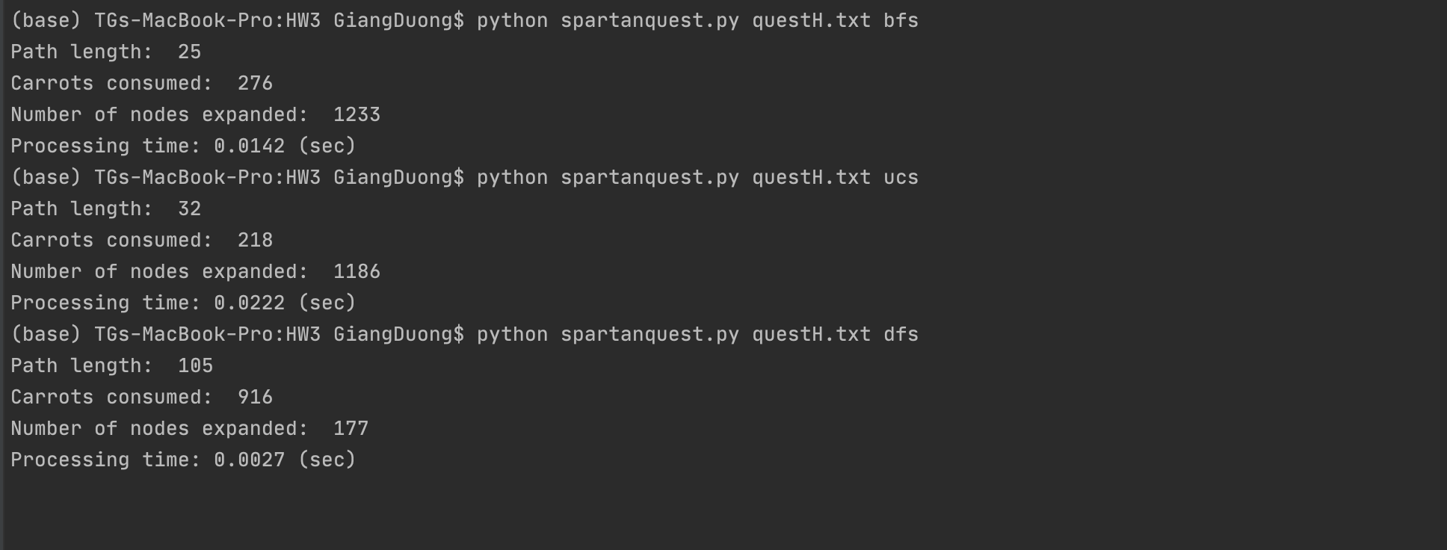

BFS:

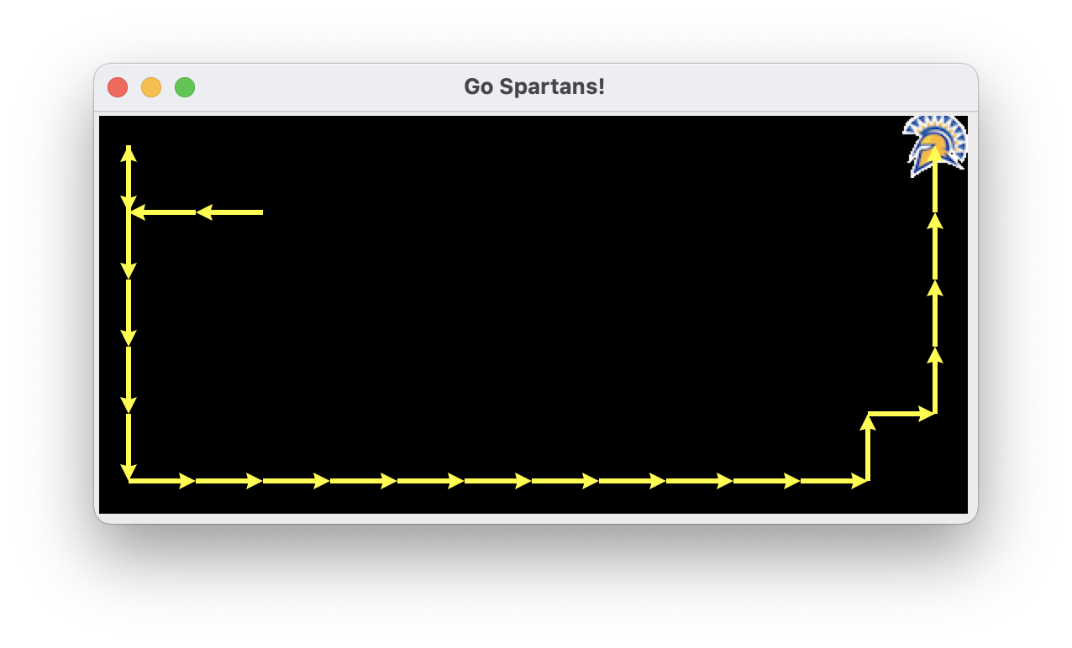

DFS:

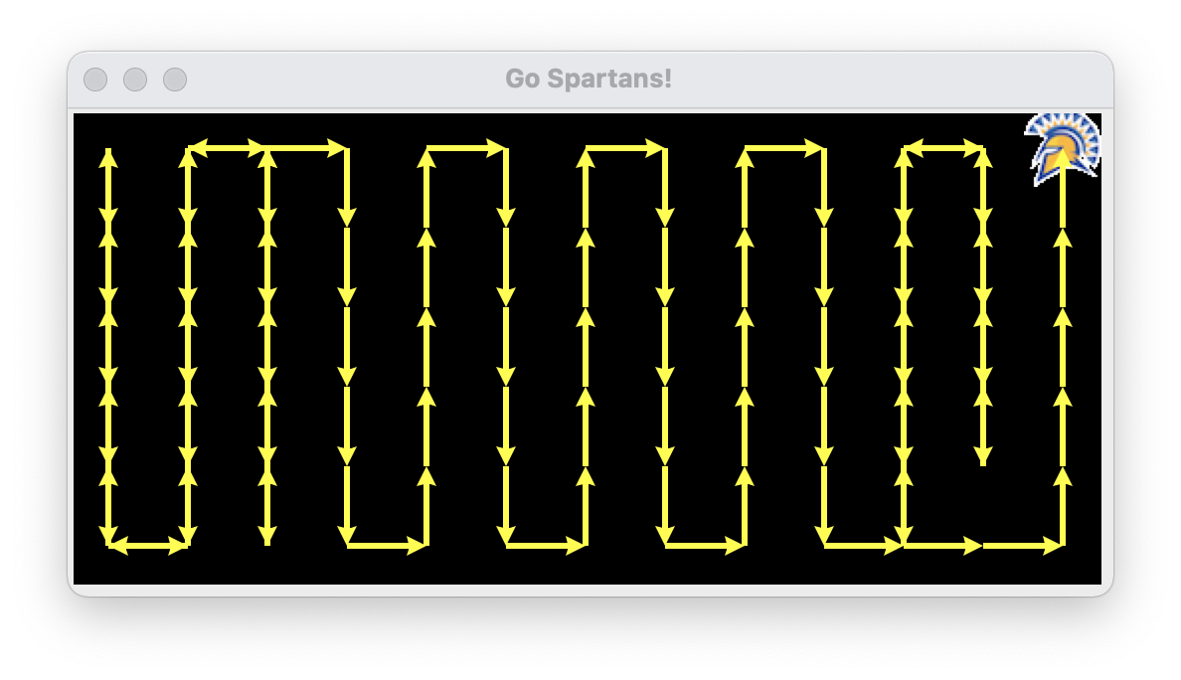

UCS:

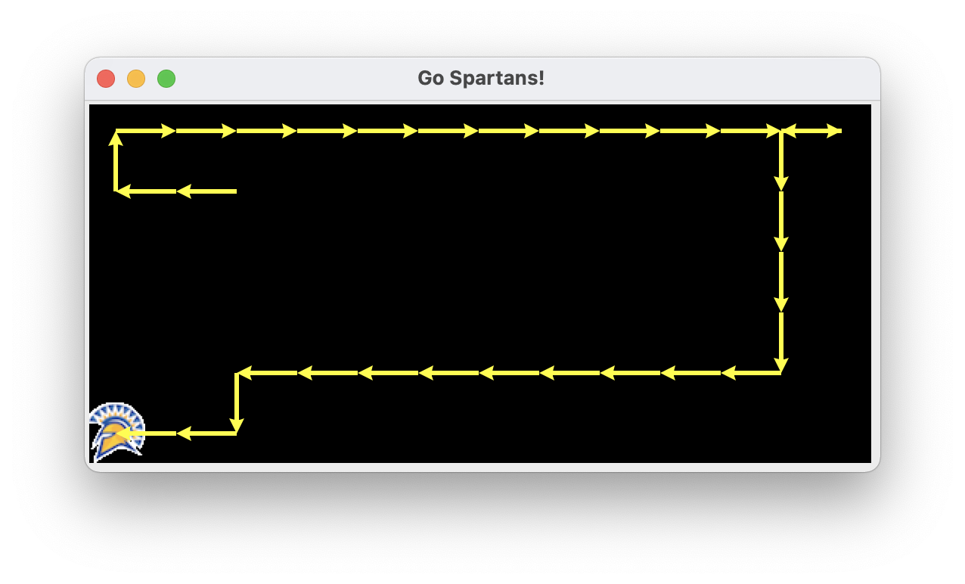

QUEST L:

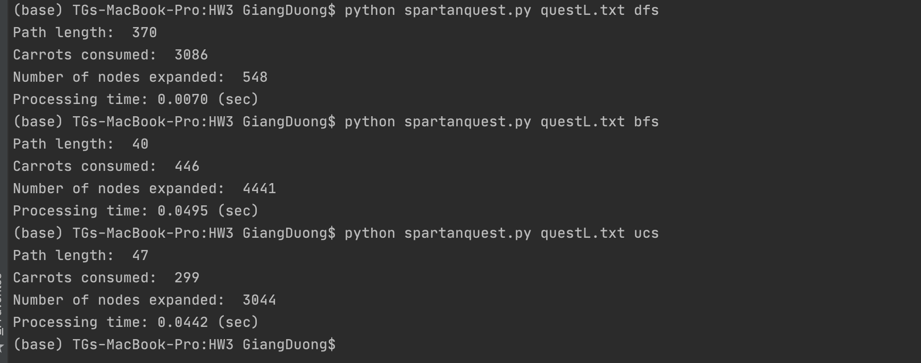

BFS:

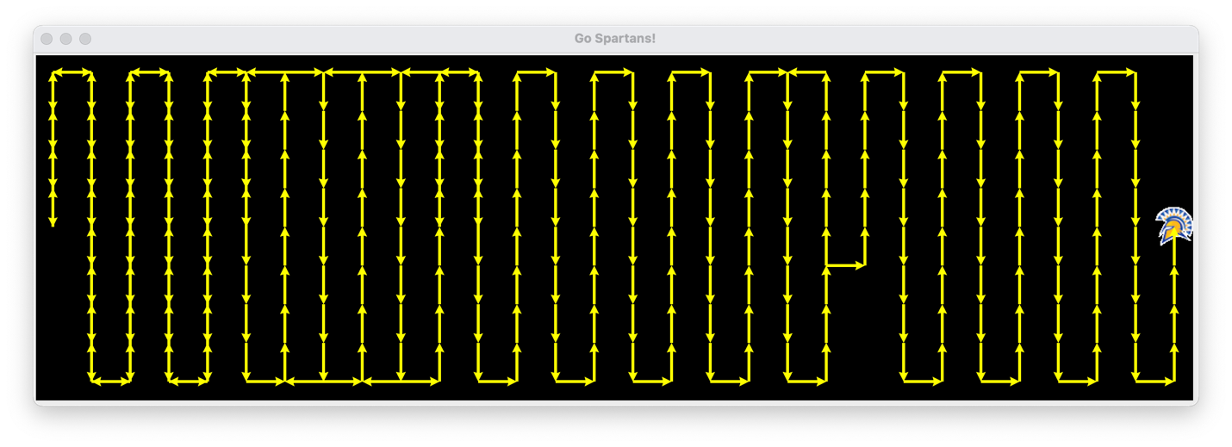

DFS:

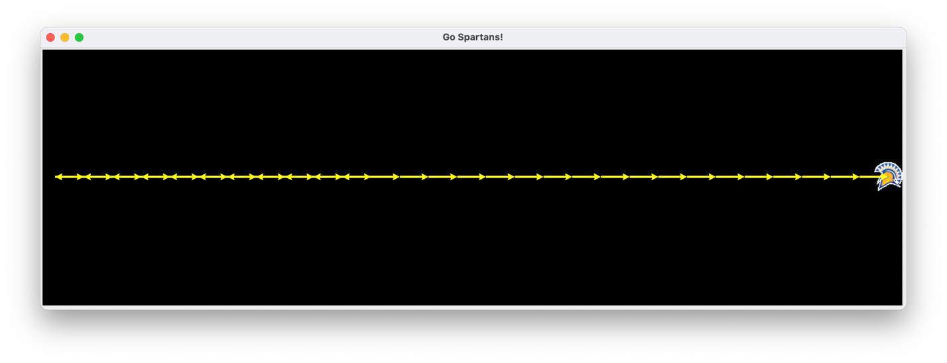

UCS:

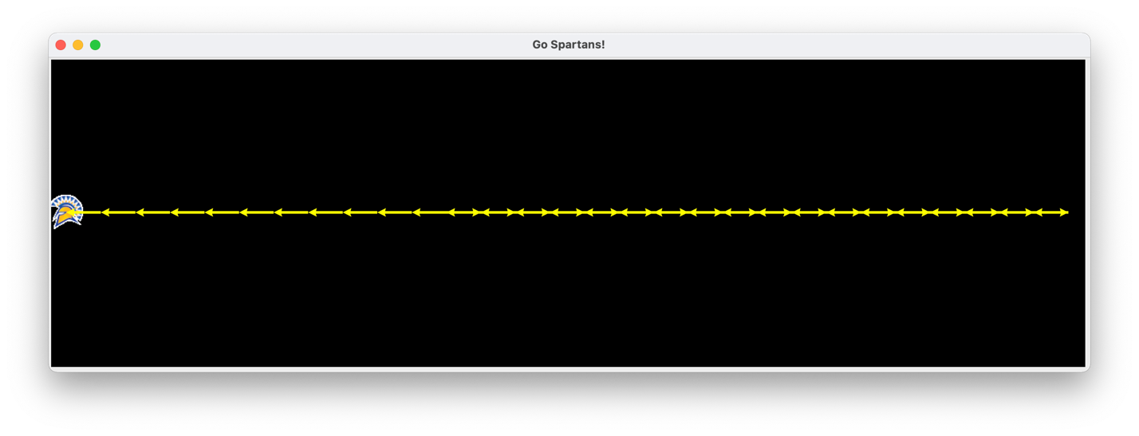

SJSU:

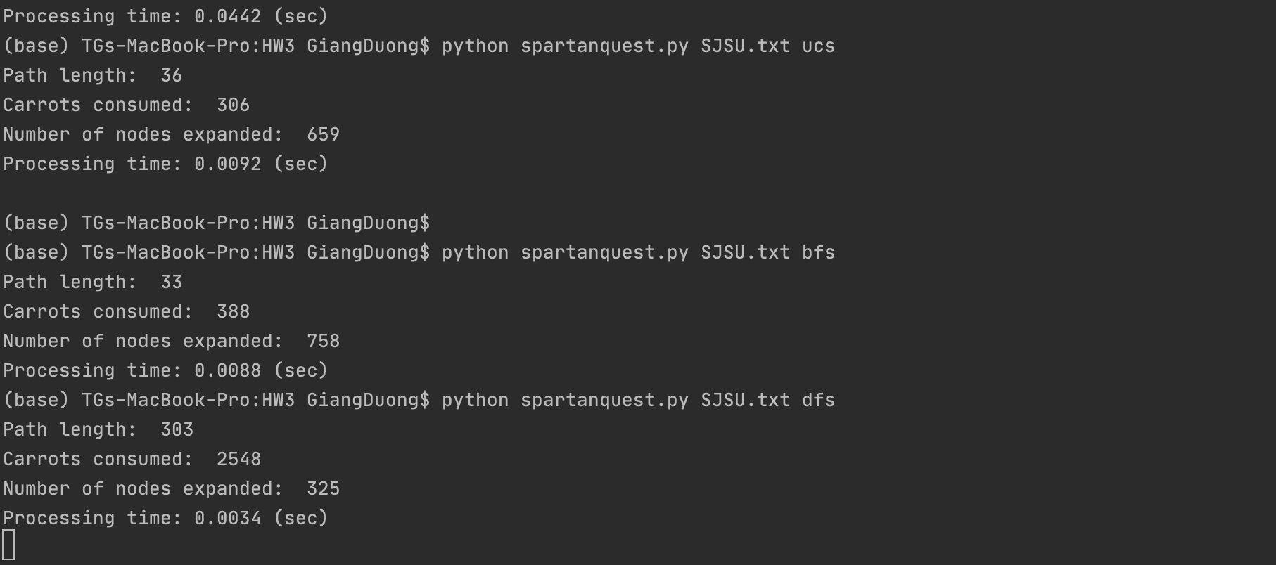

BFS:

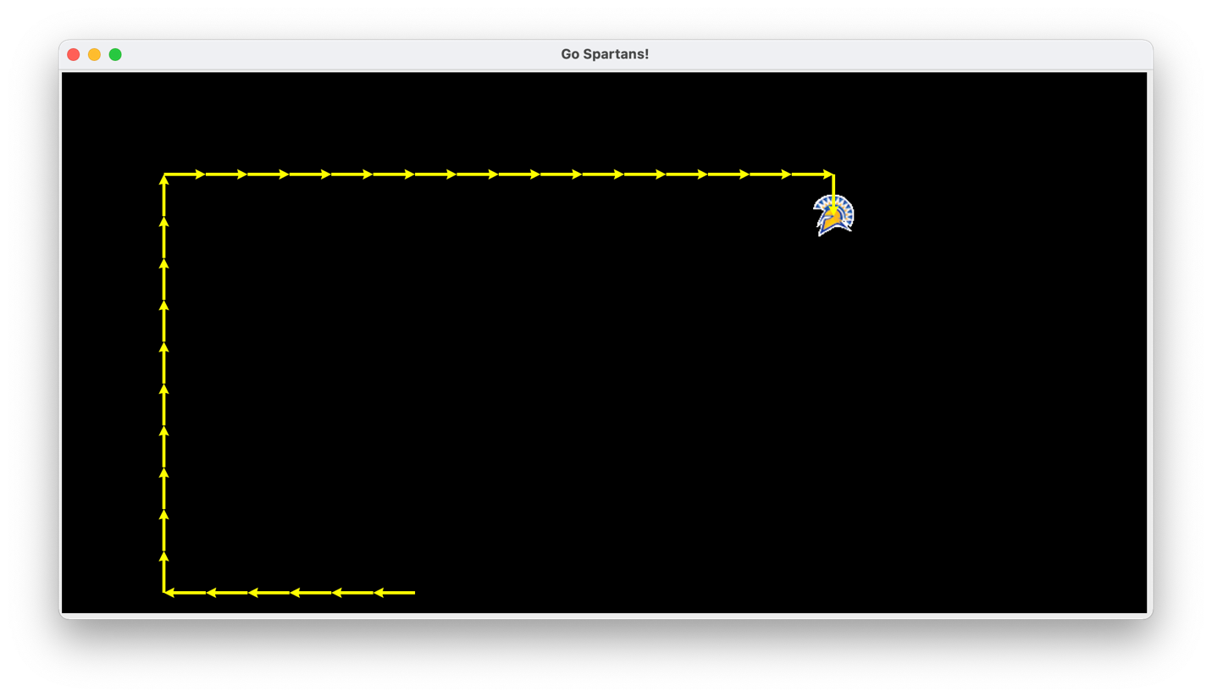

DFS:

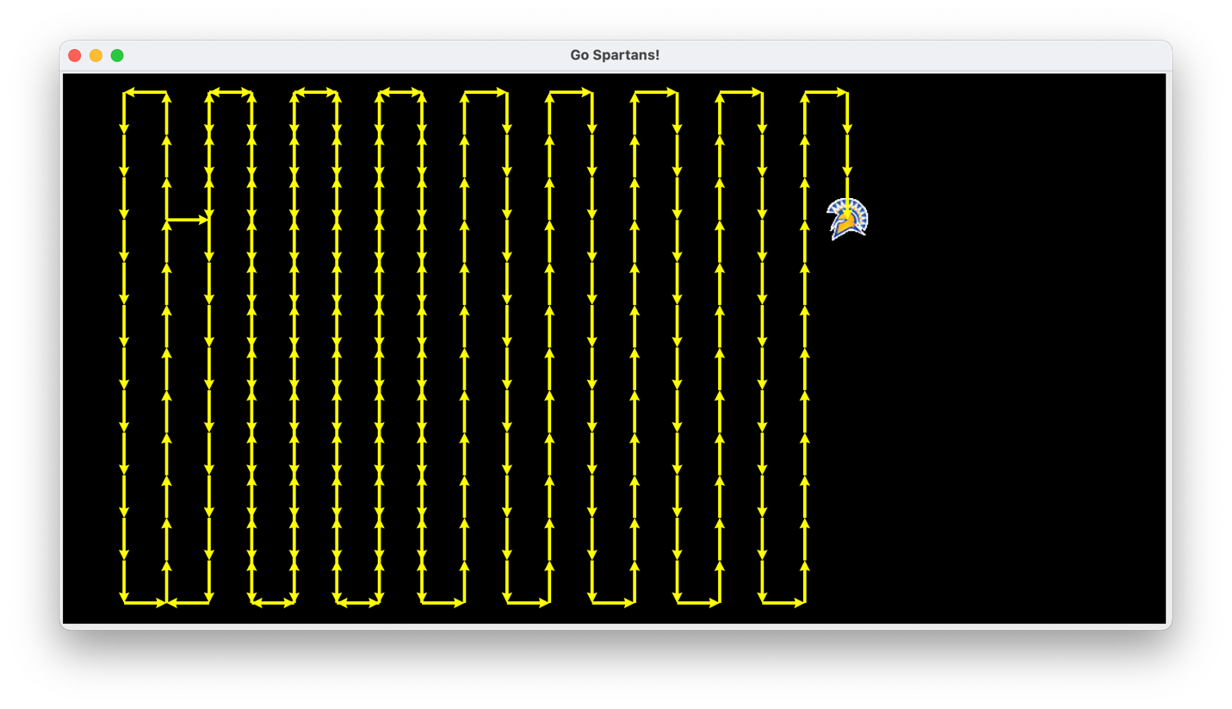

UCS:

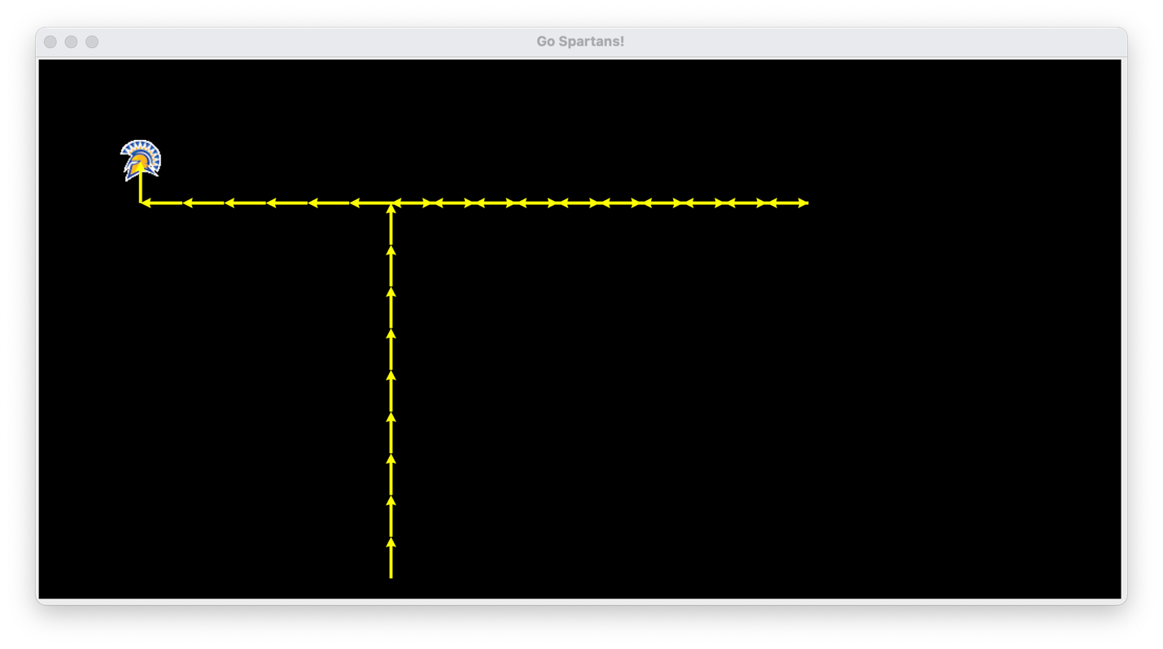

NOWAY:

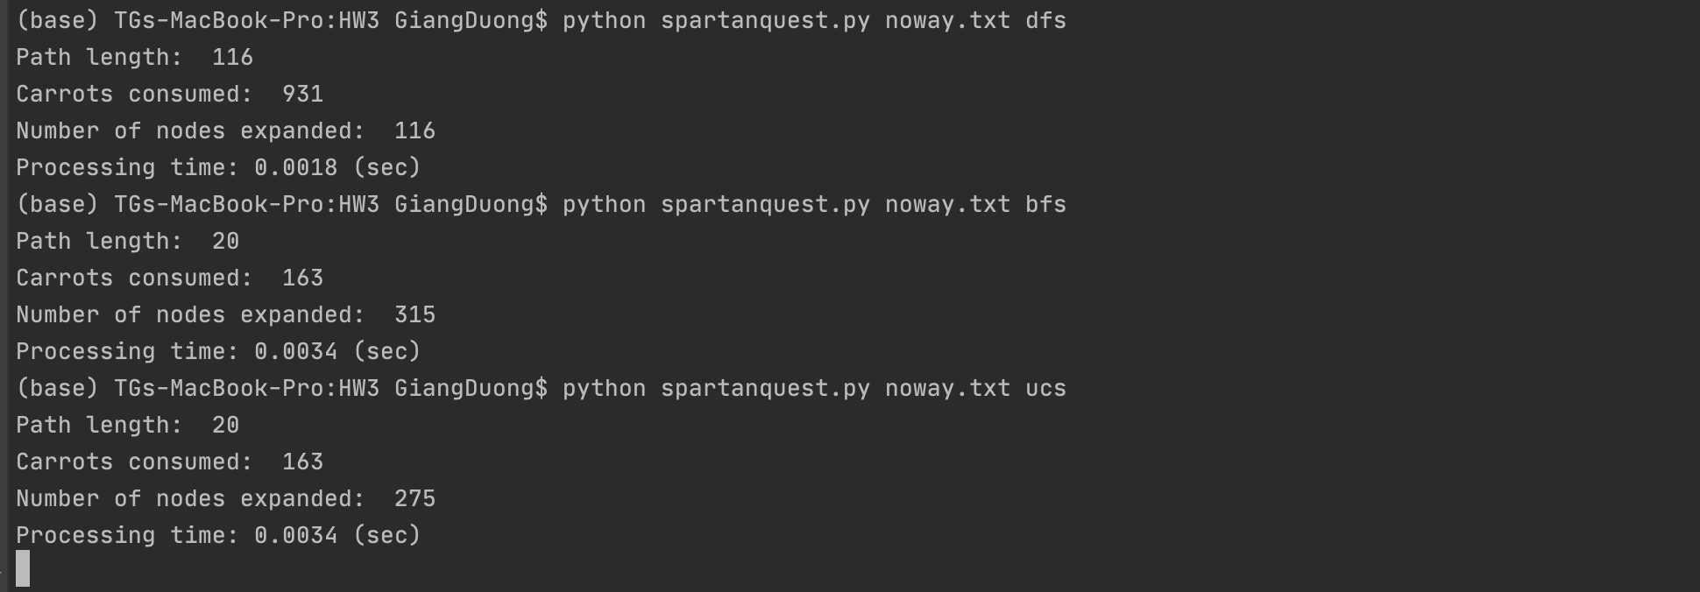

BFS:

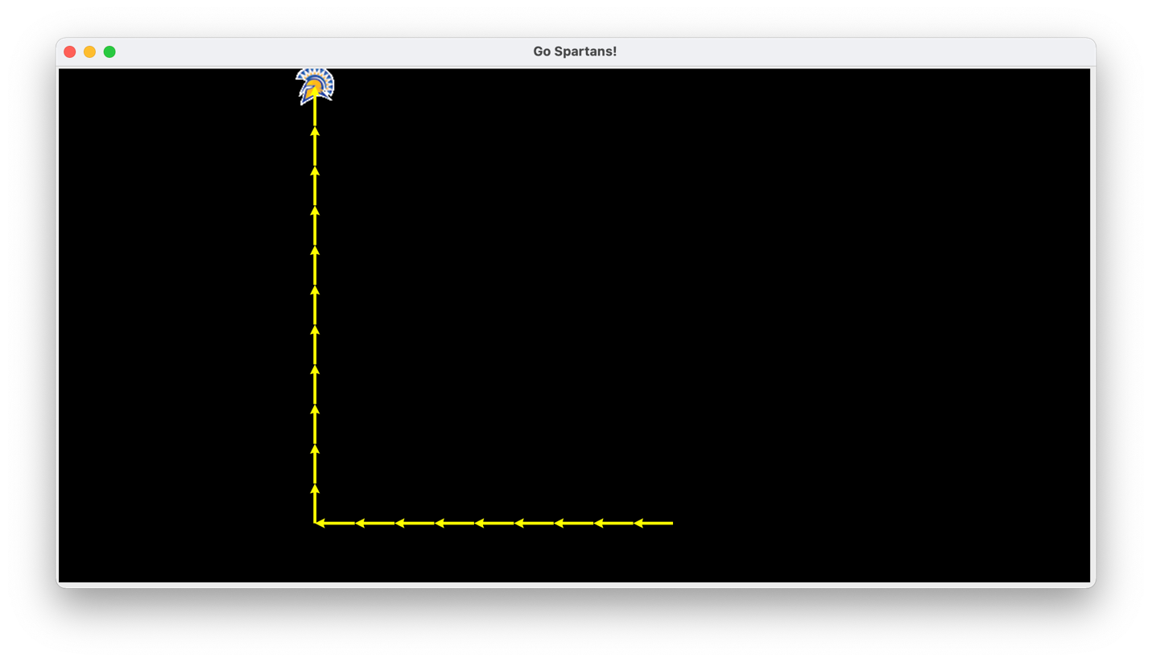

DFS:

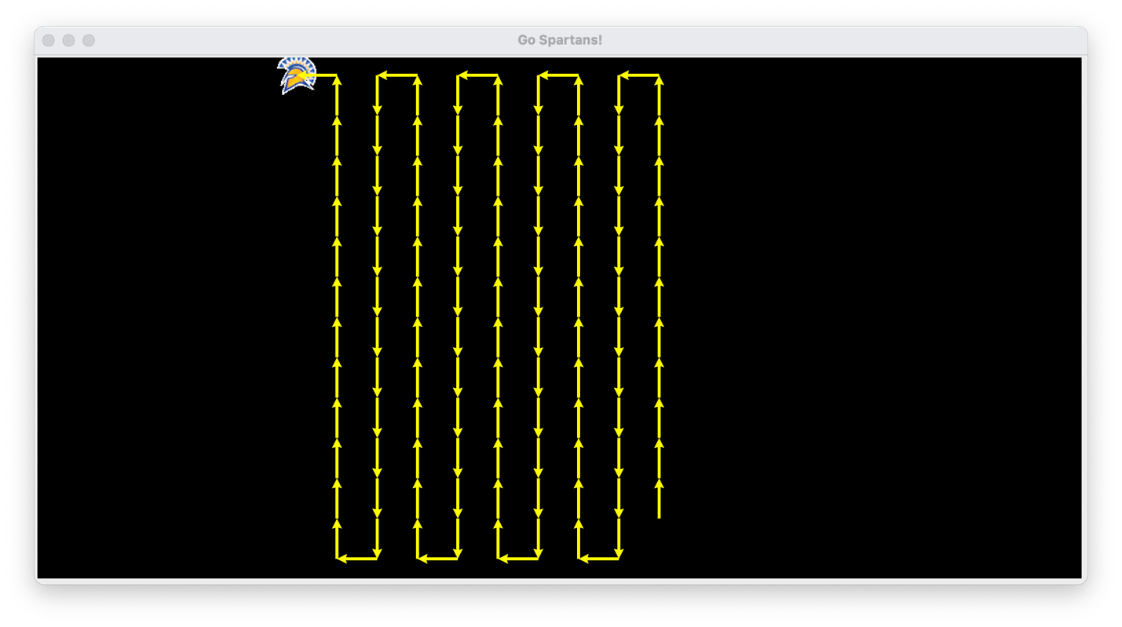

UCS:

